**Server side:**

1. Landing screen for Video upload

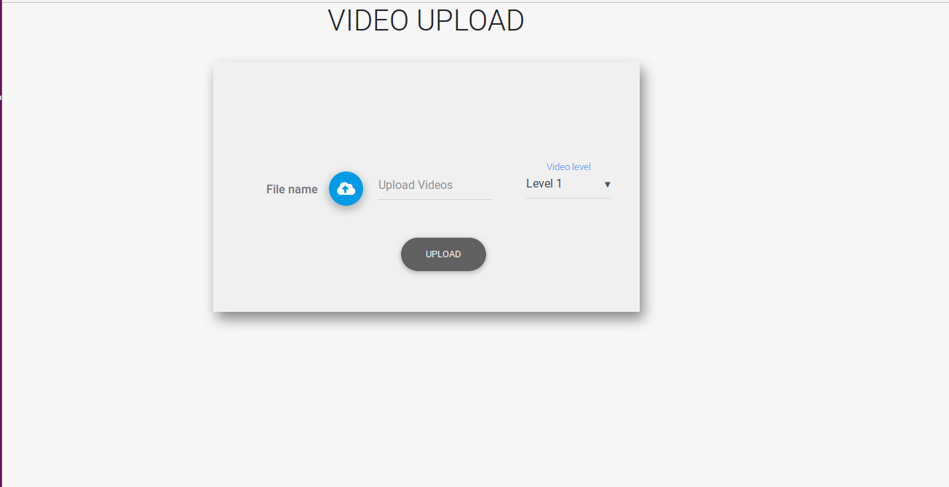

1. To select different level for the uploading the video

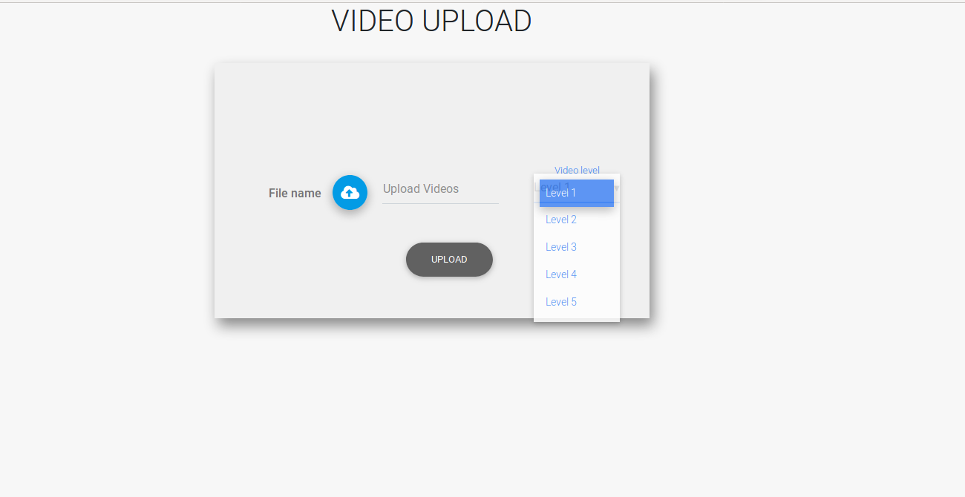

1. Admin selects different level of videos from local system

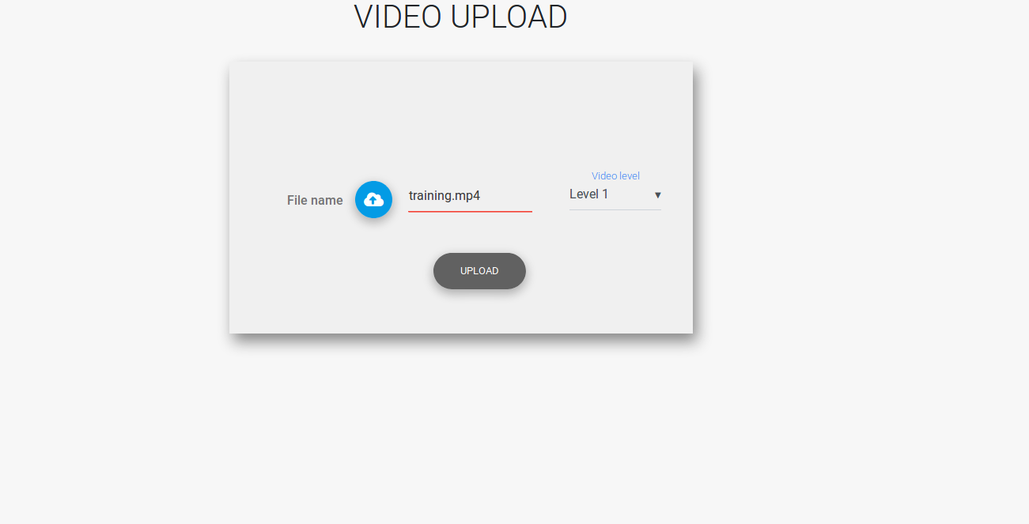

1. Clicking upload button in above pic. The video gets uploaded to the server and pause video page appears, where admin needs to pause each video and answer the shot location and shot type.

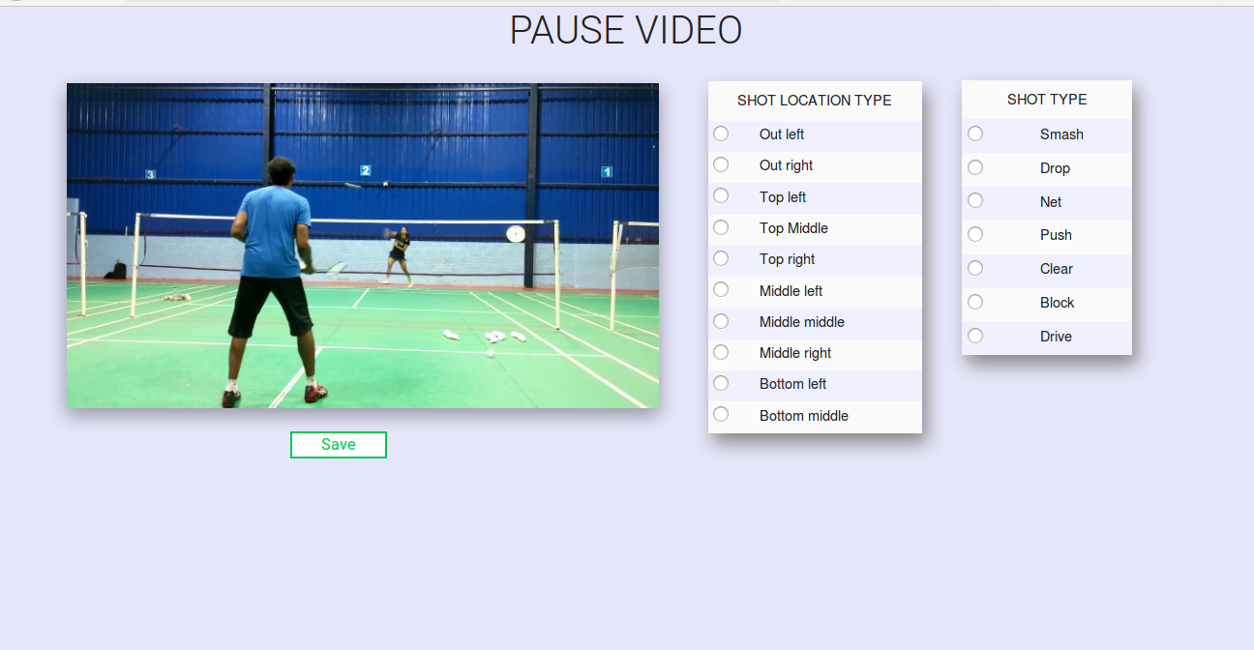

1. Admin pauses the video by clicking on the video layout. Pause time appears, with shot location and shot type to be selected from the table. 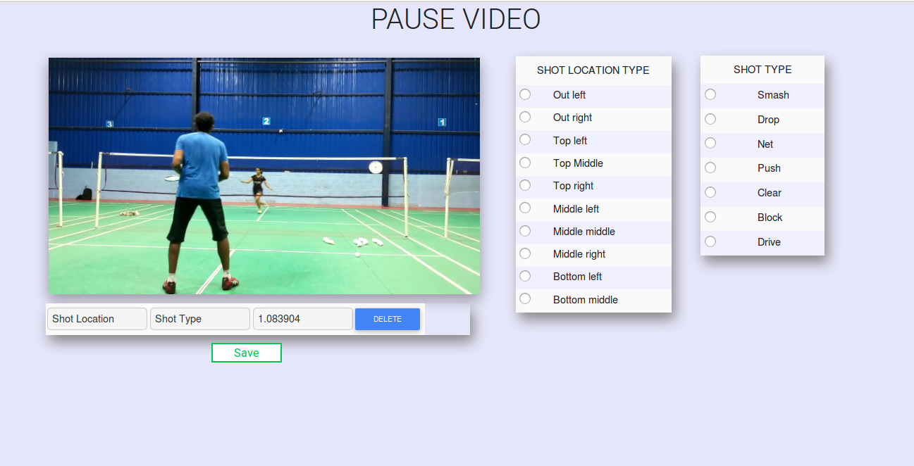
2. Admin selects shot type and shot location and clicks the video to resume the video. 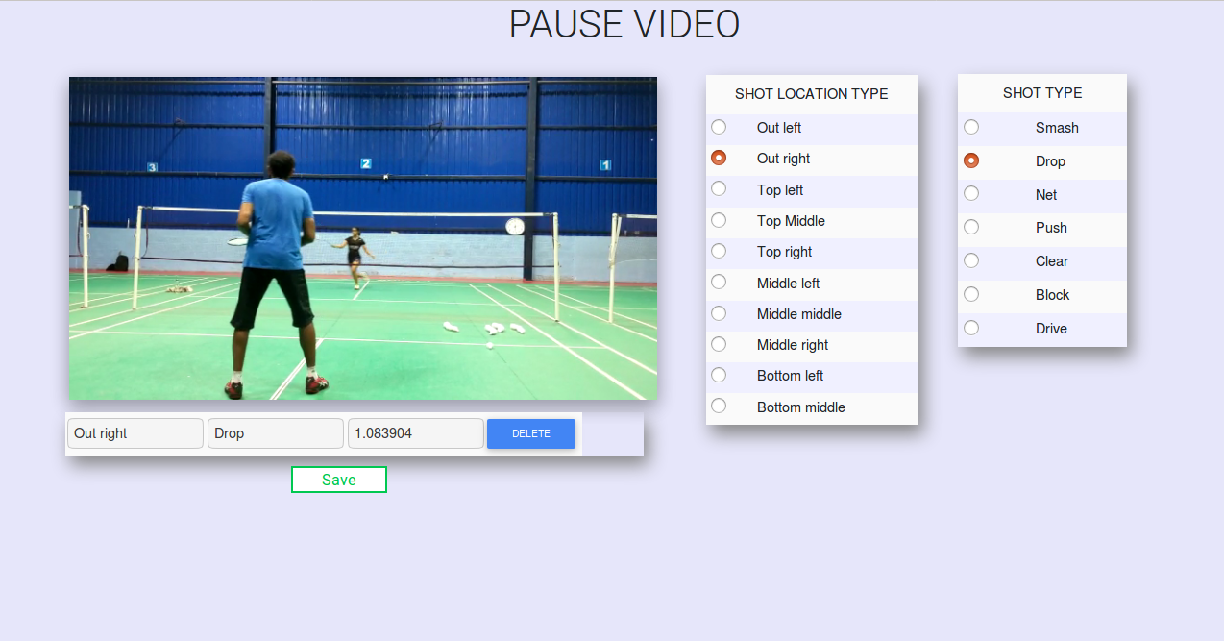
3. Admin pause the video and selects shot location and shot type

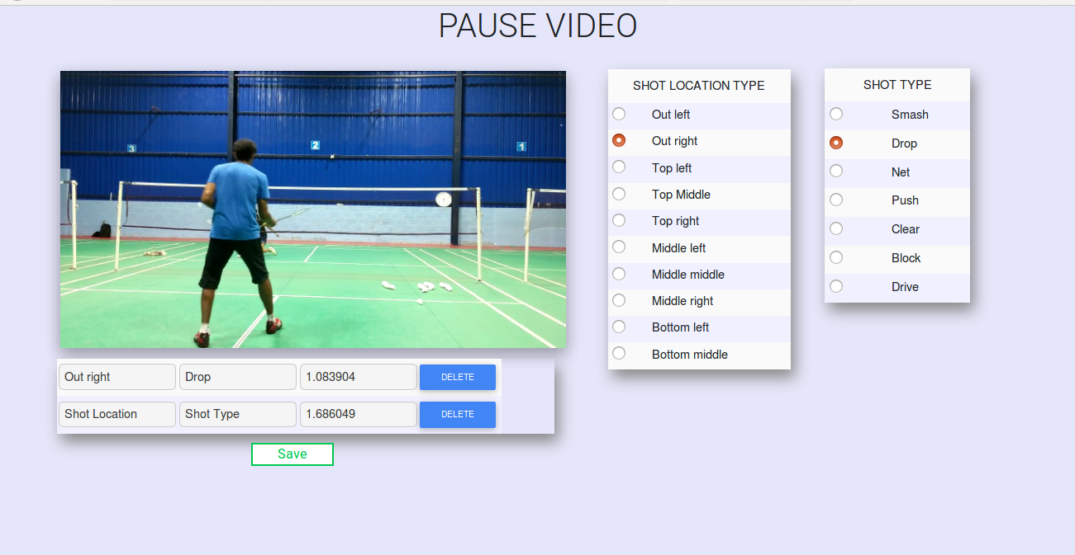

1. Admin pause the video for 3rd time but won’t select shot location and type.

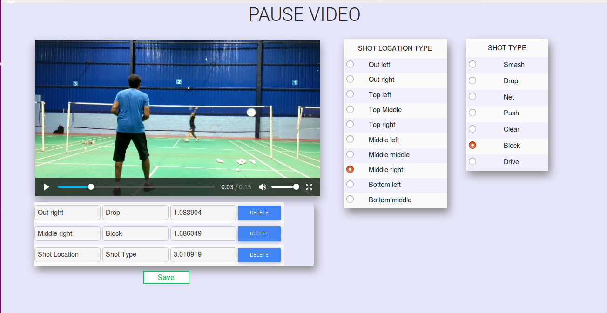

1. Admin clicks save button, as admin hasn't selected shot location. Pop up message appears.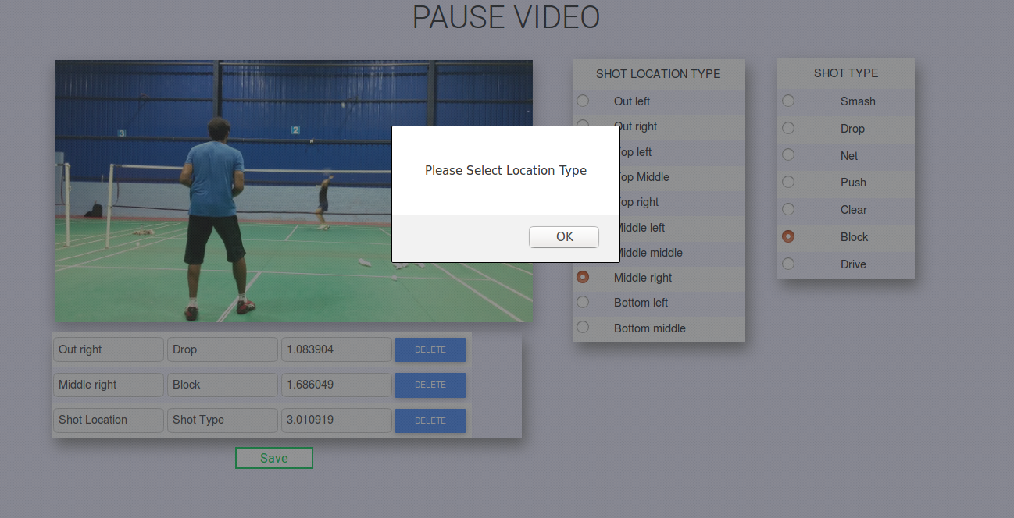
2. Admin selects shot location but doesn't select shot type Pop up message appears. 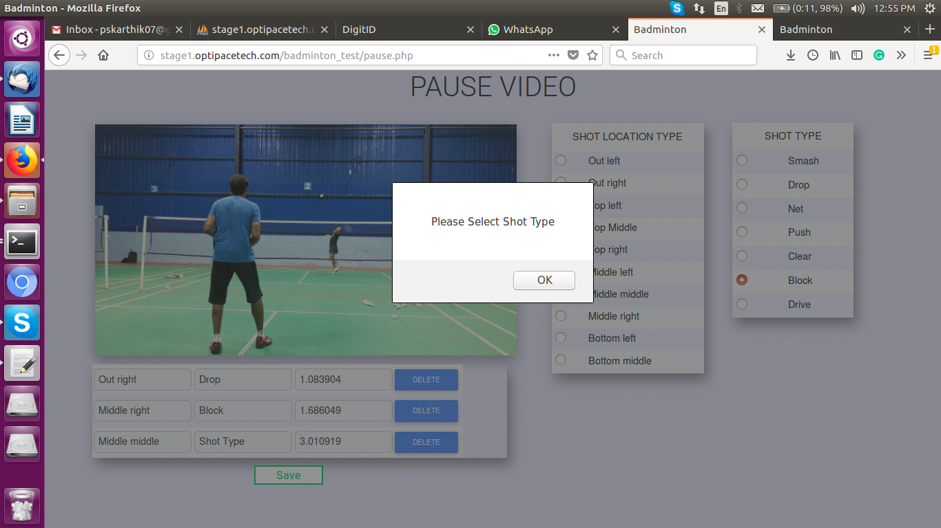
3. Admin clicks save button. 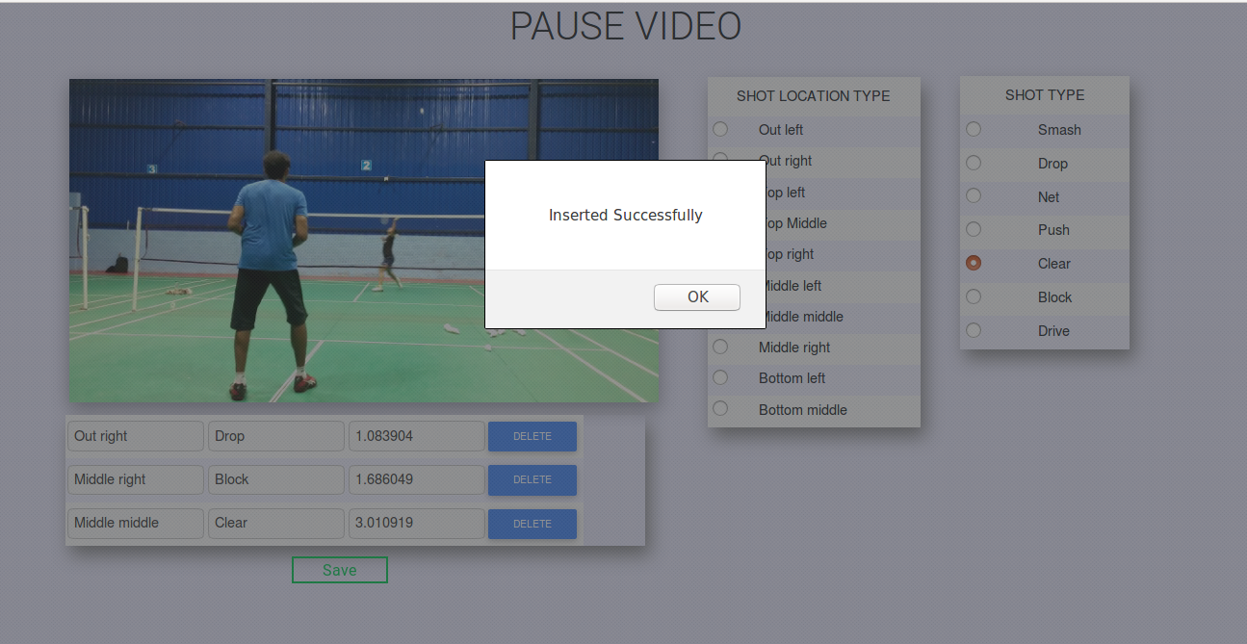

**Payment mode:**

1. Sample registration form

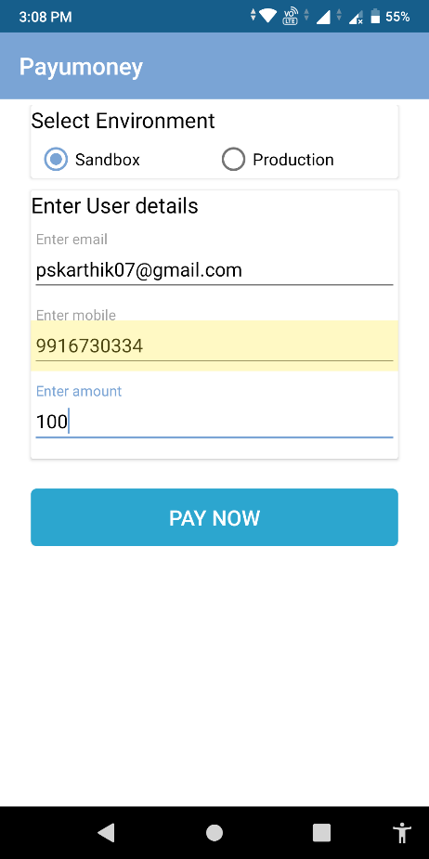

1. On Clicking Pay now Button in above pic

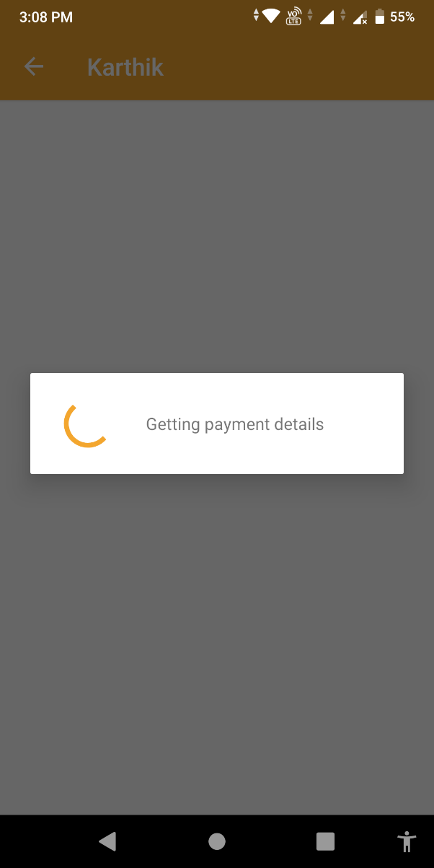

1. Payment details GUI from ccavenue. 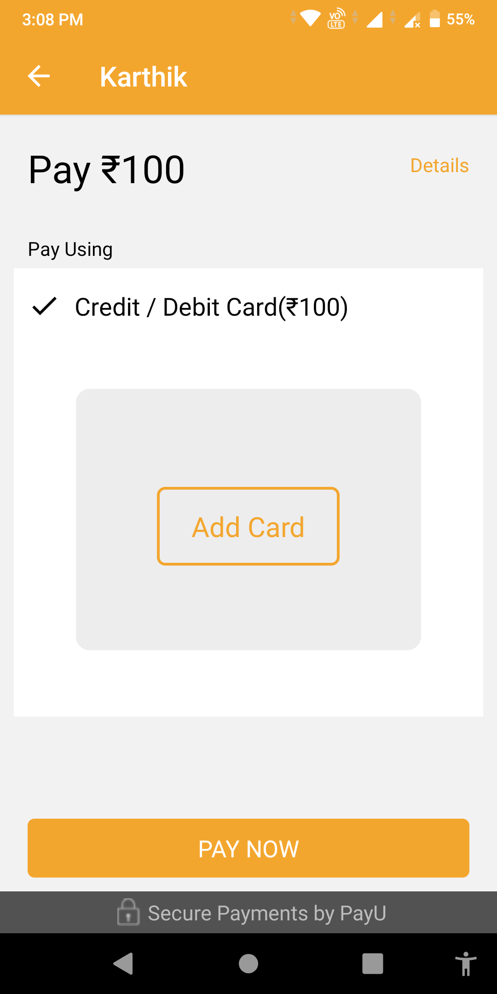
2. user needs to fill card details

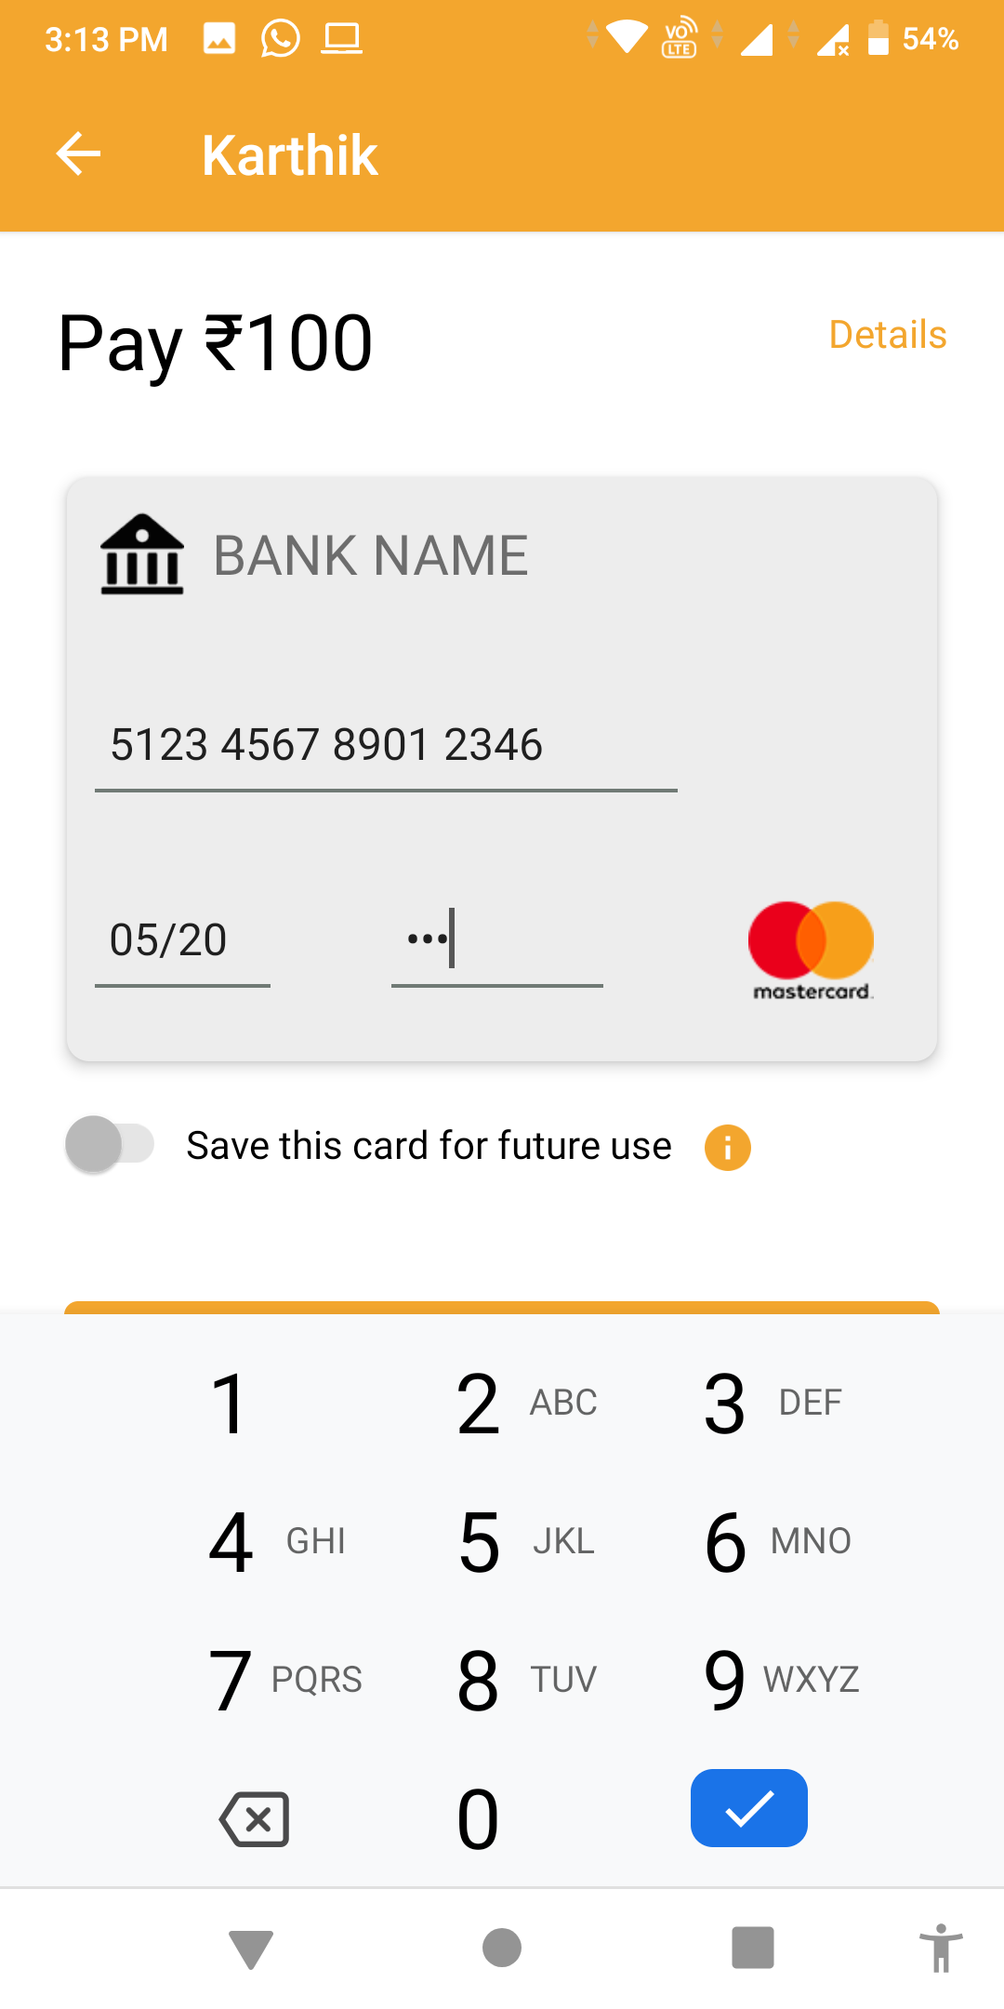

1. 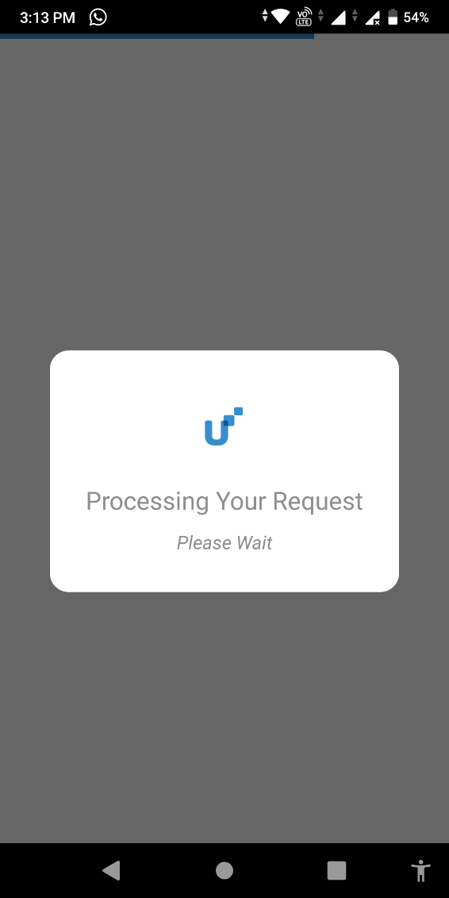On Clicking paynow button, ccavenue process the request for OTP.

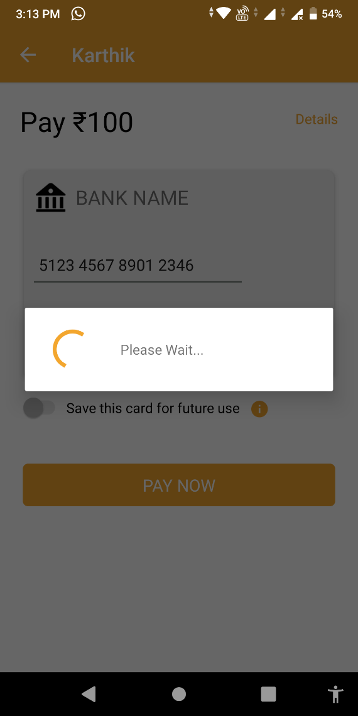

1. Corresponding bank OTP form appears.

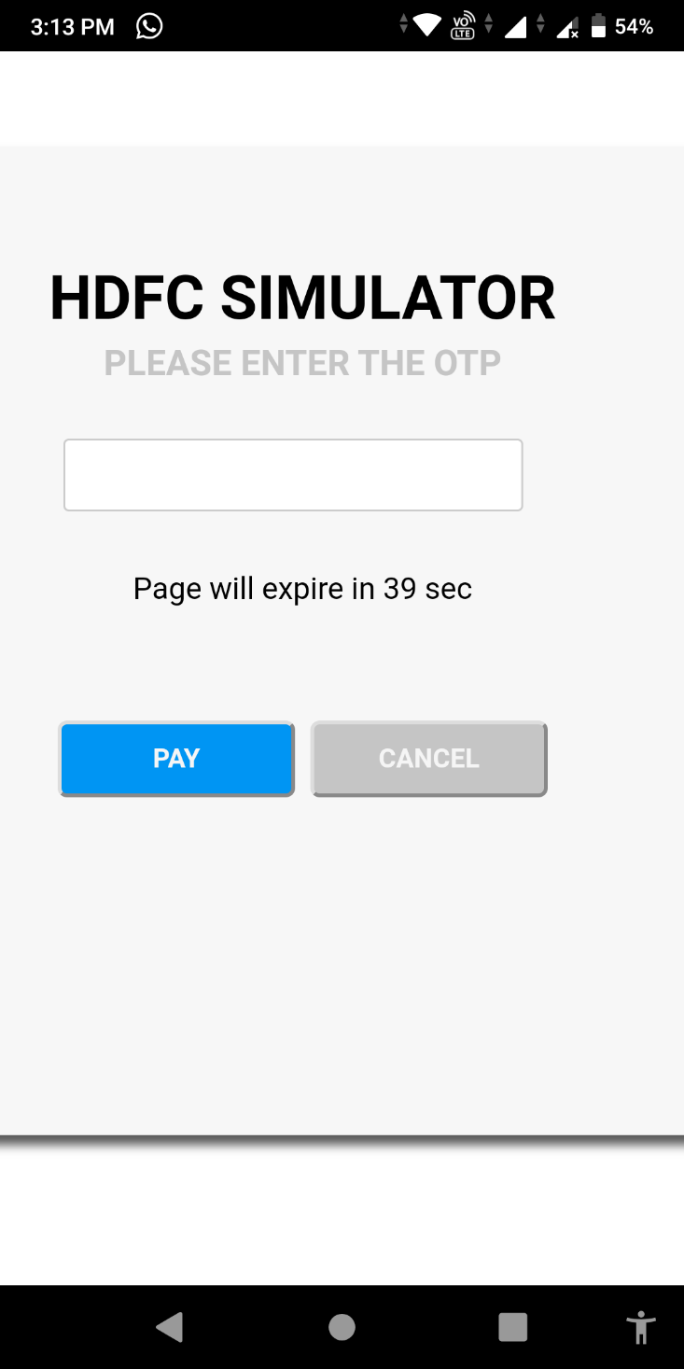

1. user enters OTP

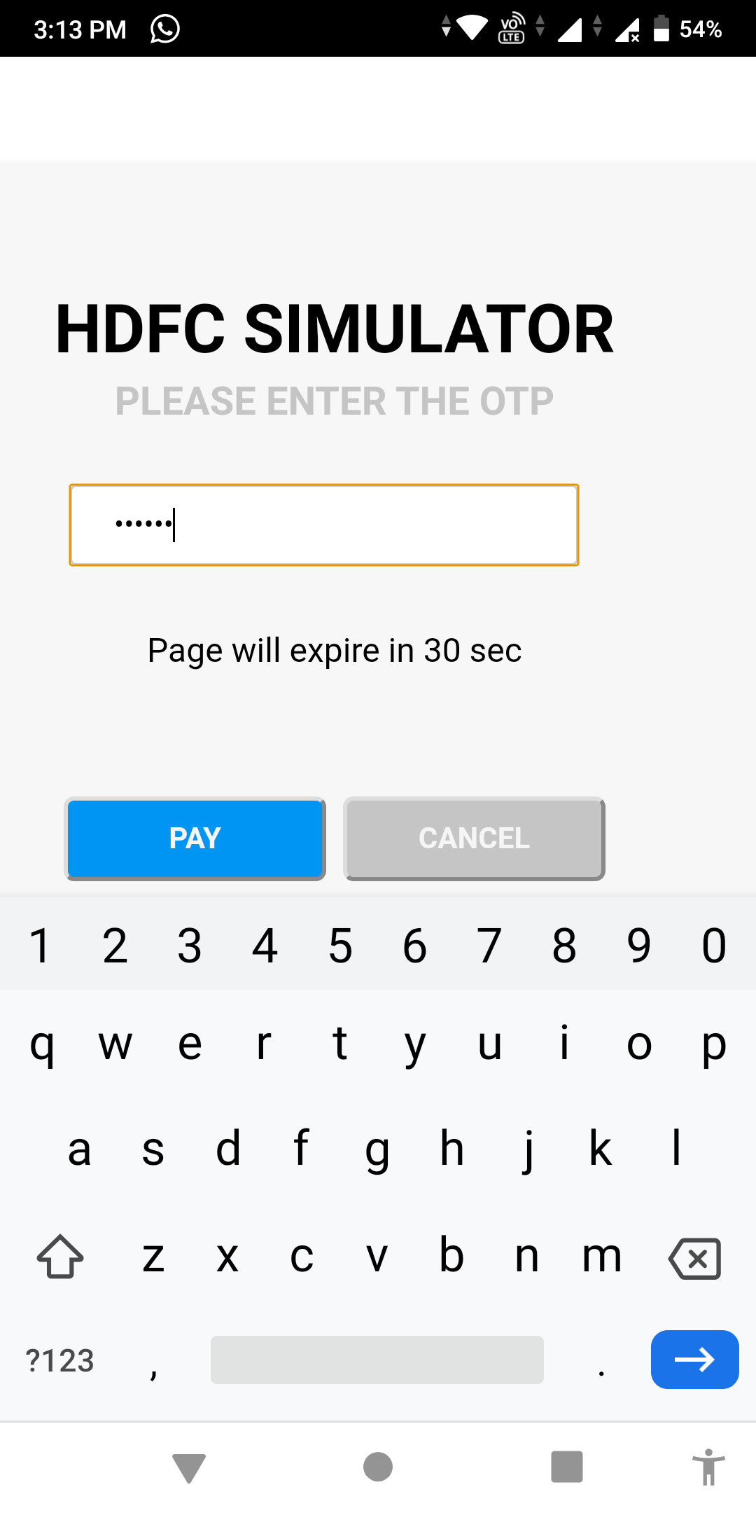

1. On Clicking pay, successful message appears.



**Sign In:**

Enter the registered user name and password to sign in.

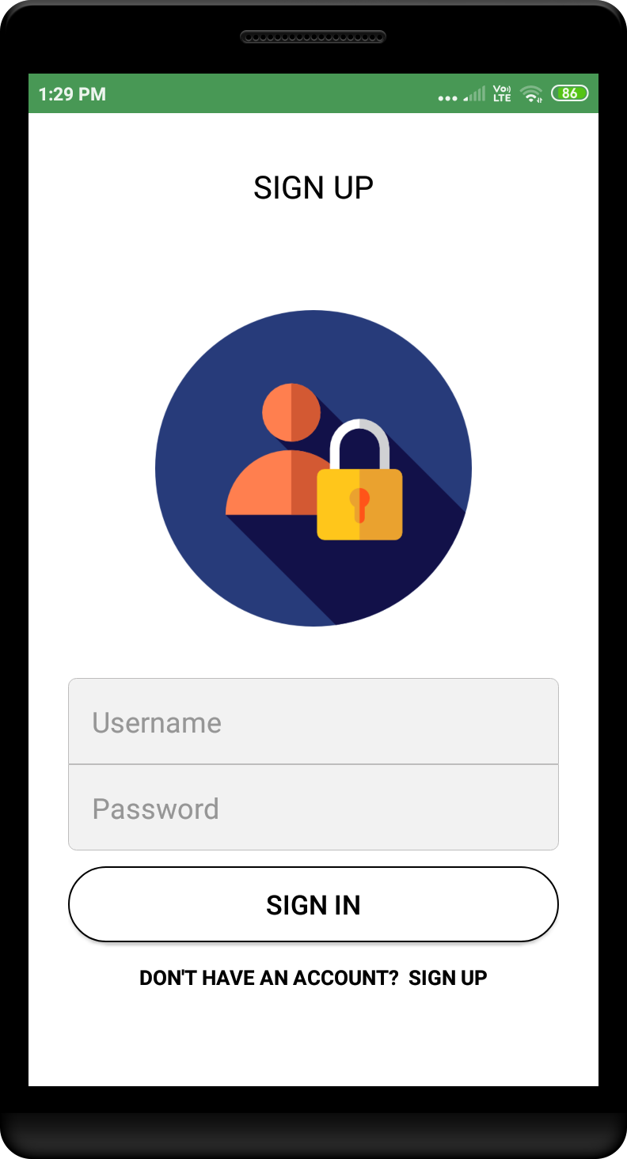

**Sign Up:**

New user registered here

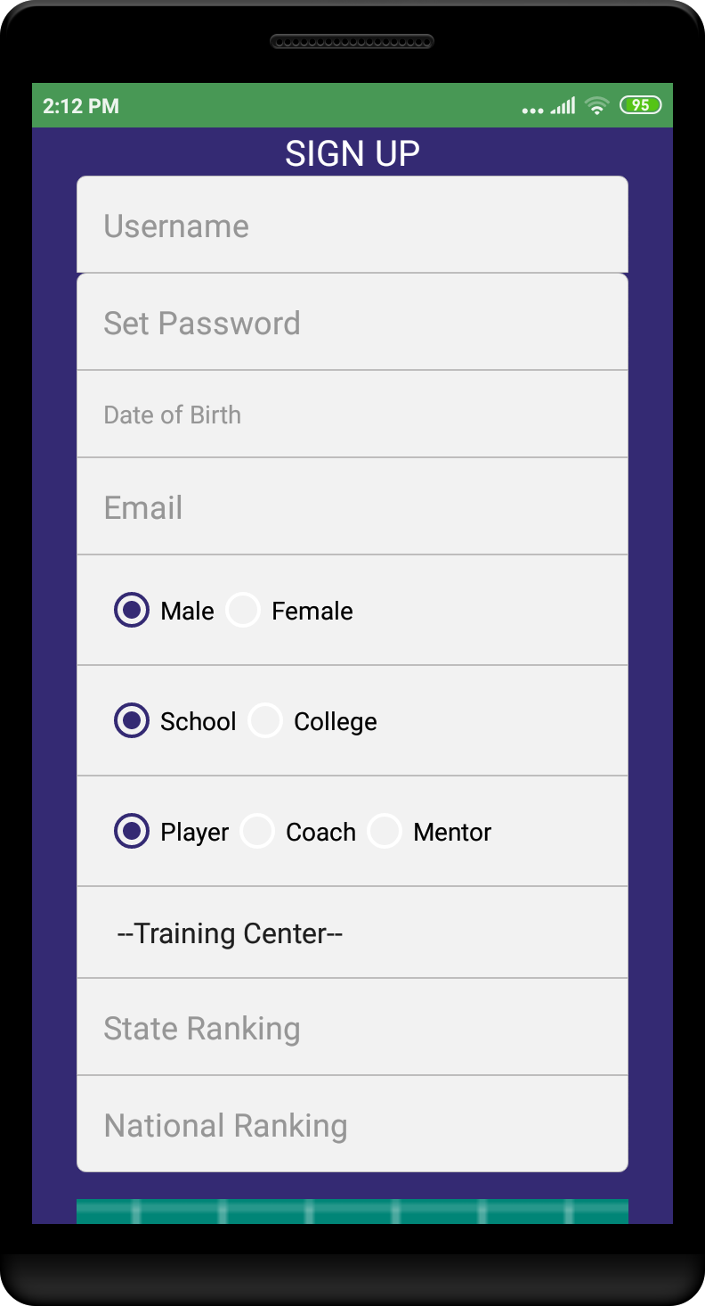

After Sign In:

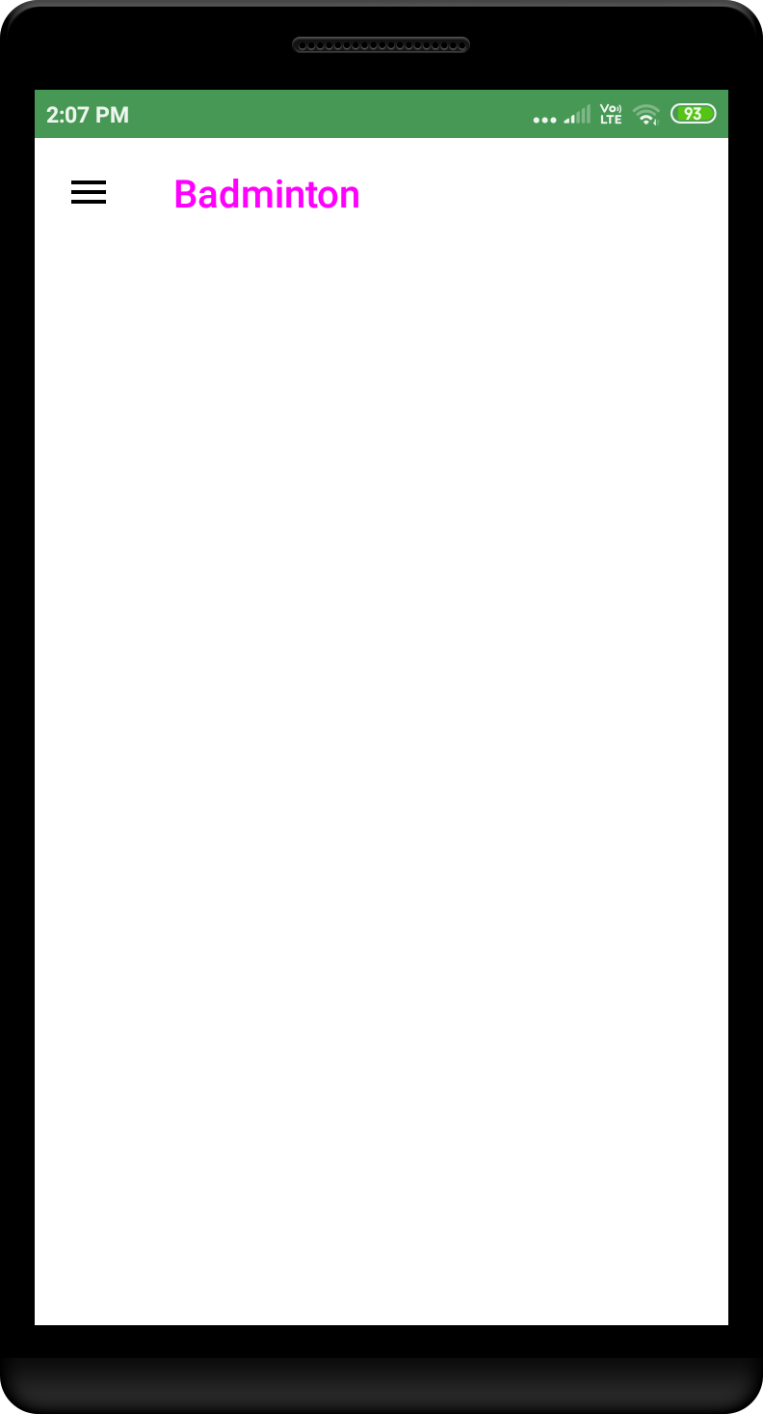

Options in the navigation.

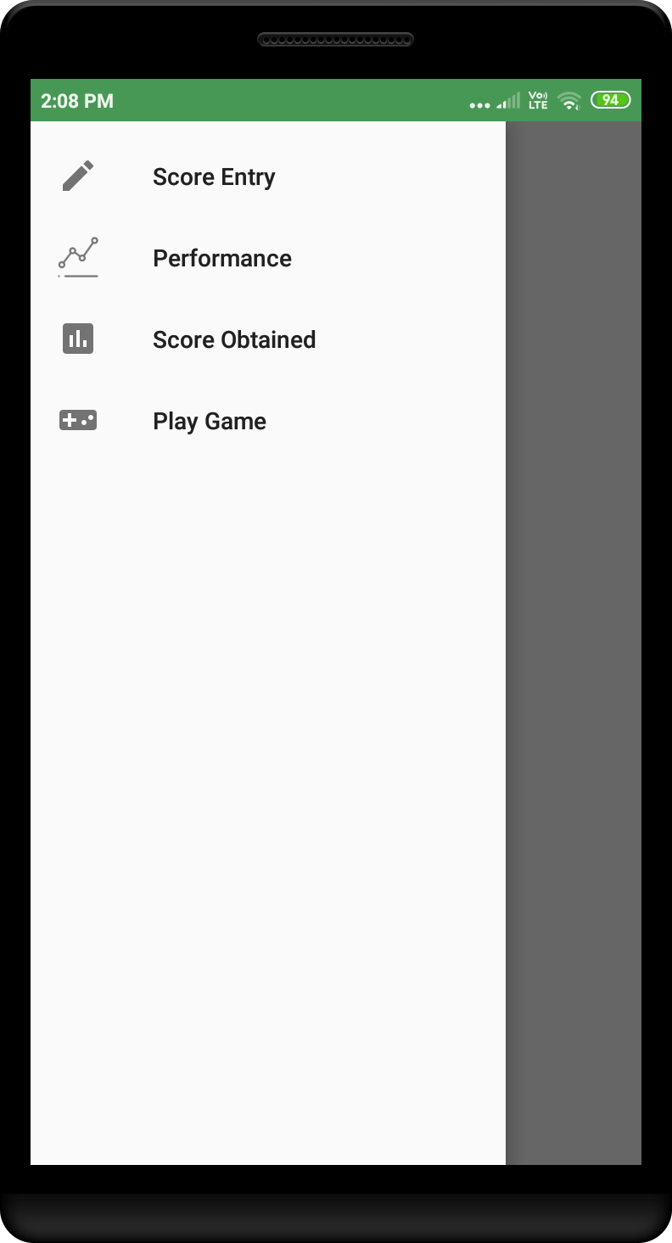

On Clicking score entry:

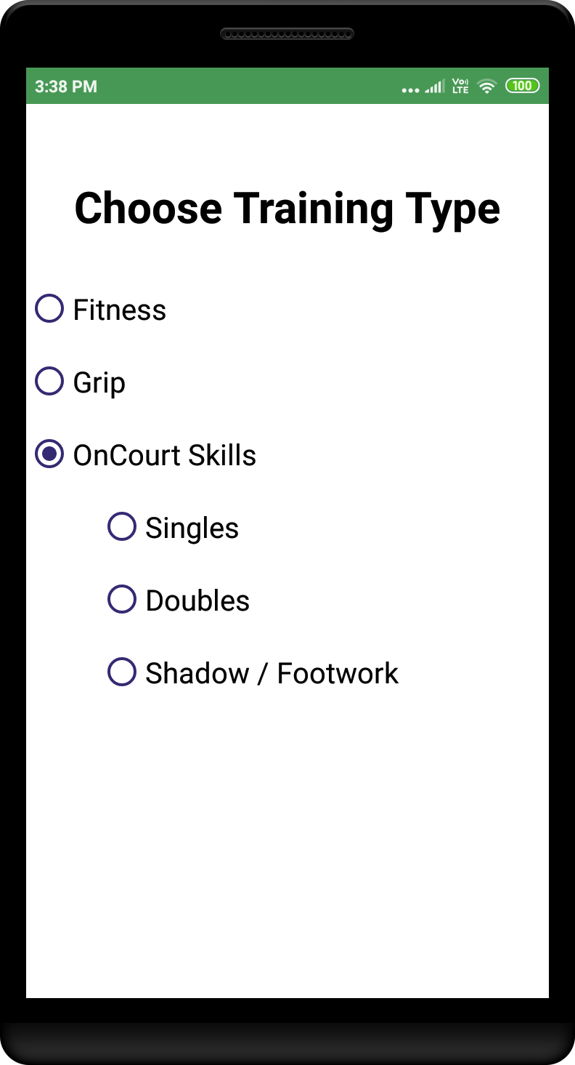

On clicking fitness:

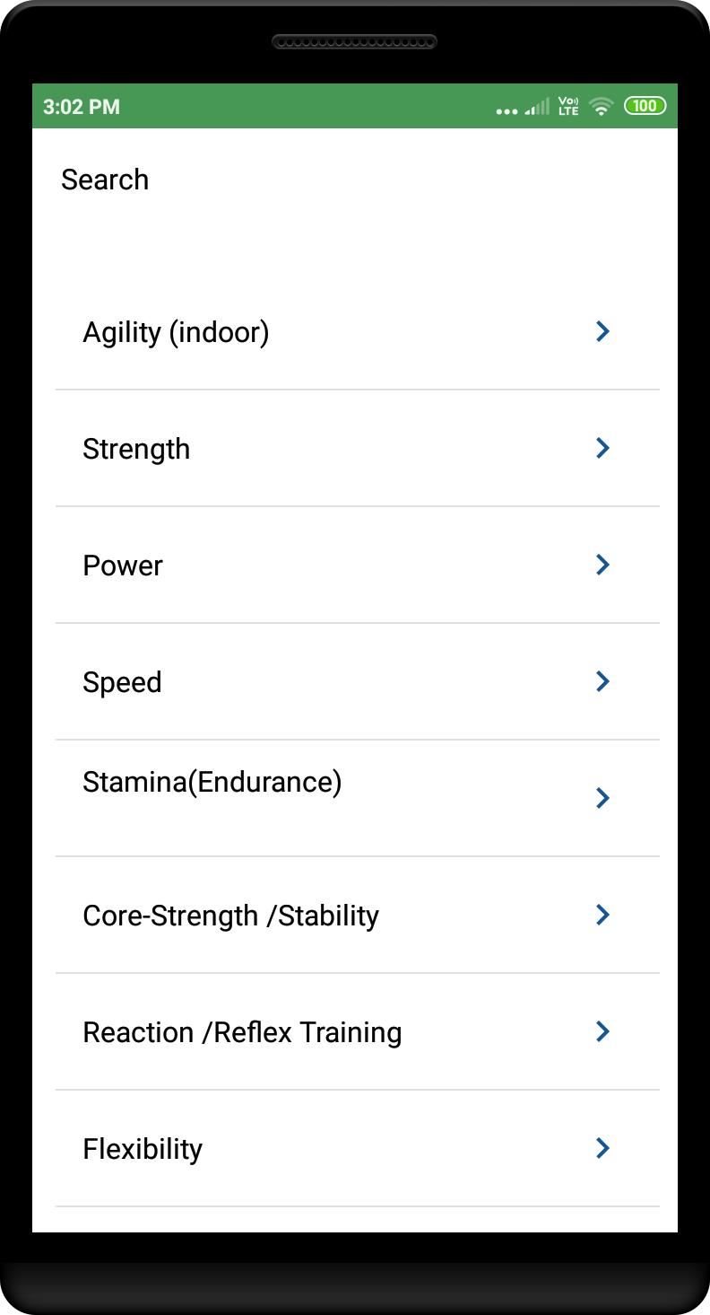

On clicking Agility:

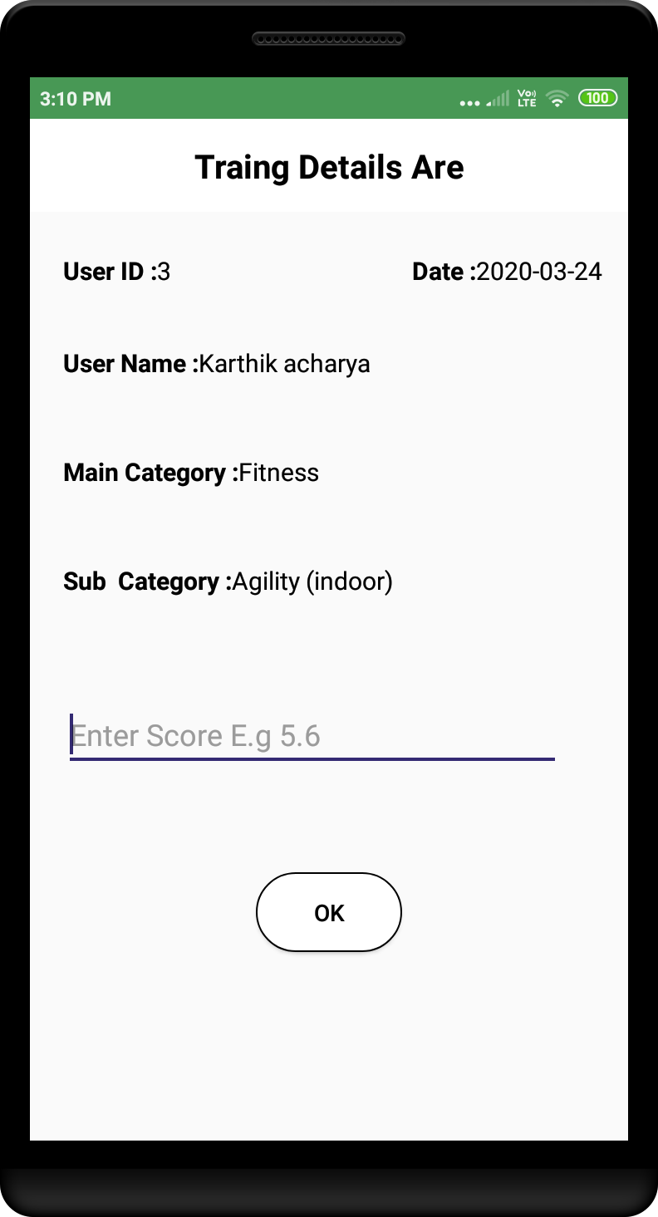

On Clicking grip under training type

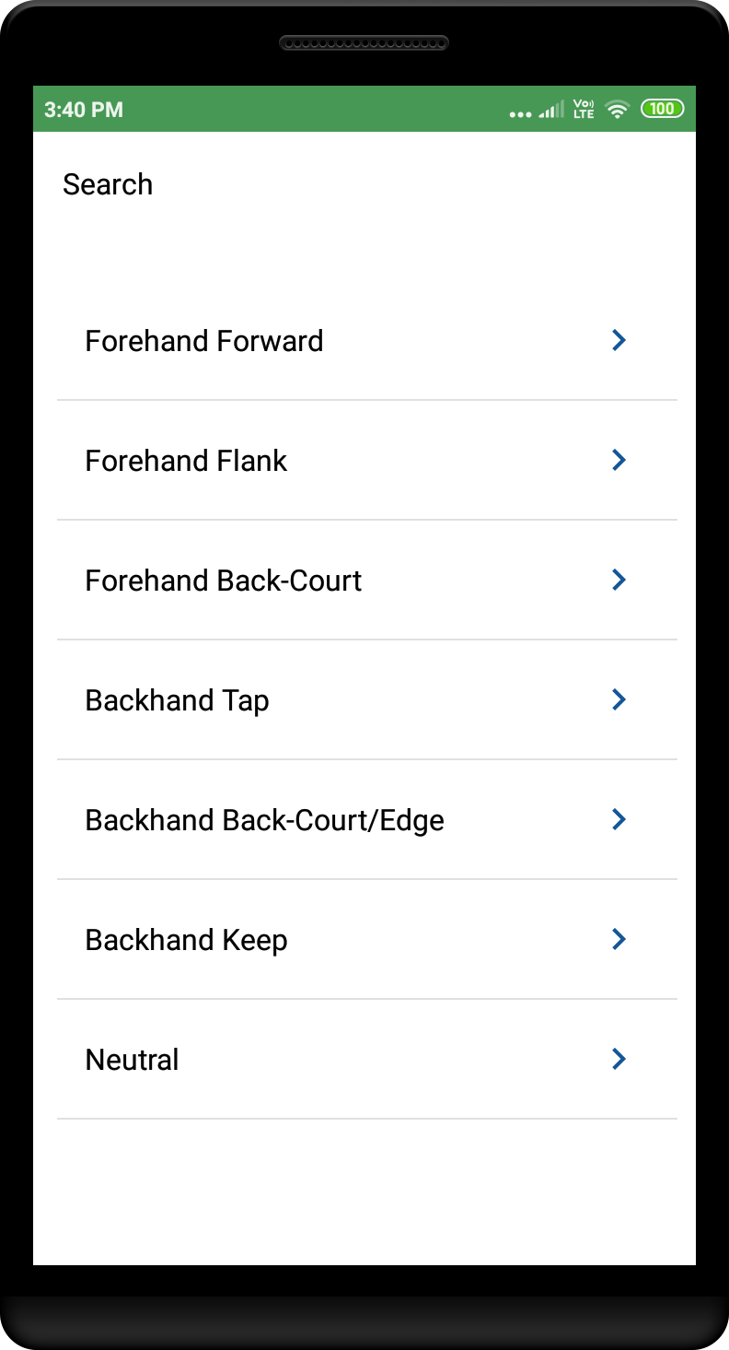

On clicking Forehand forward under Grip

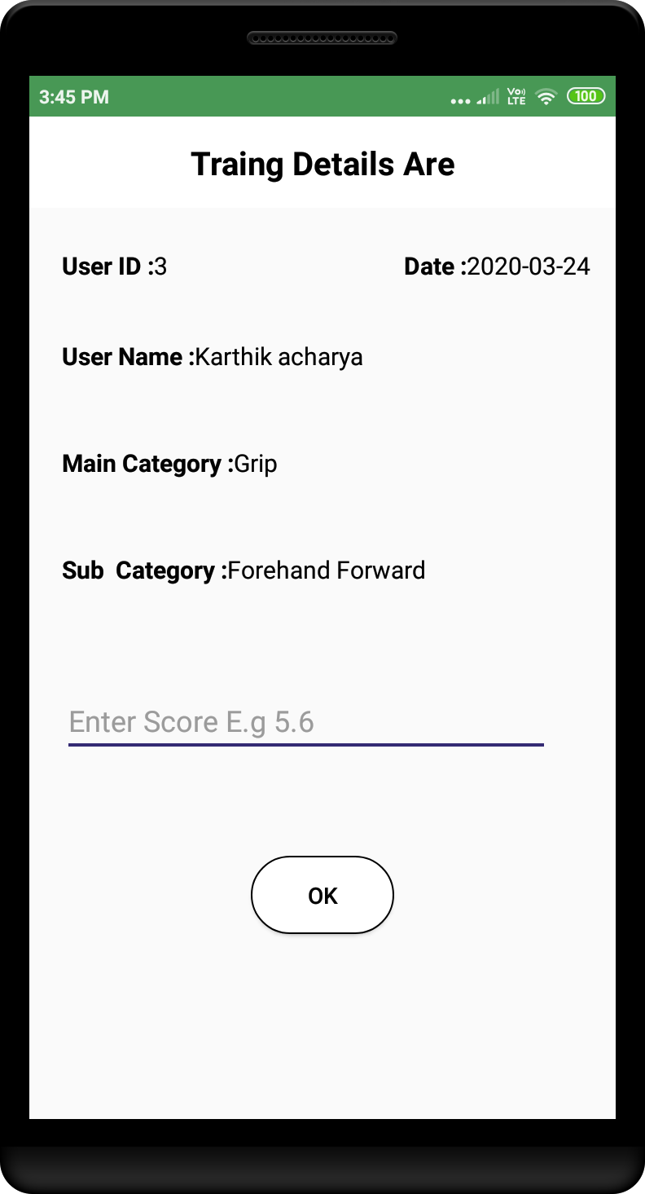

On court option, under singles

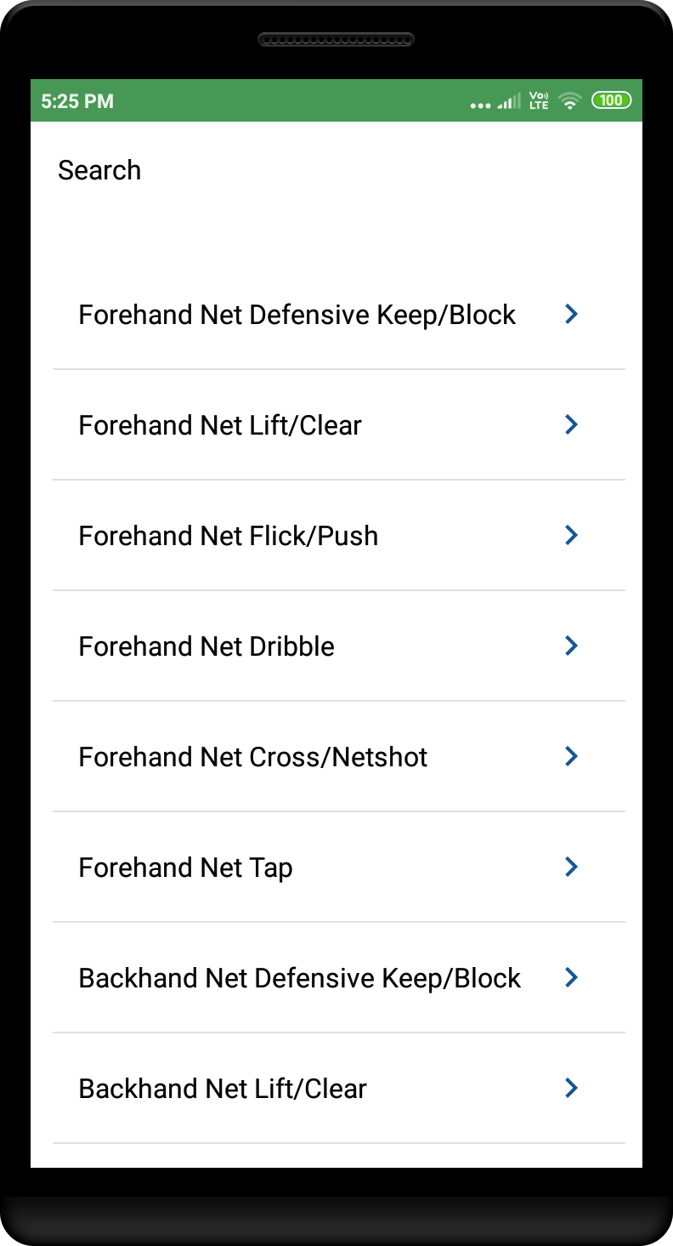

Under Doubles

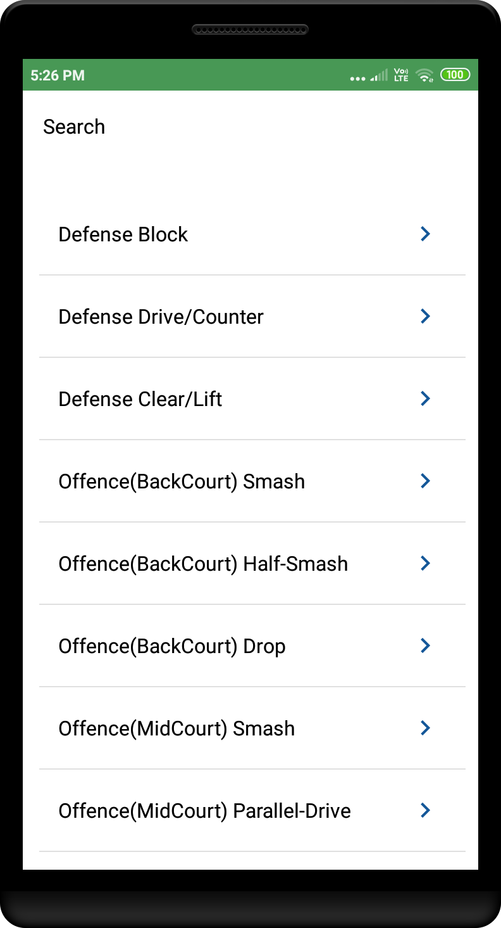

Under shadow/footwork

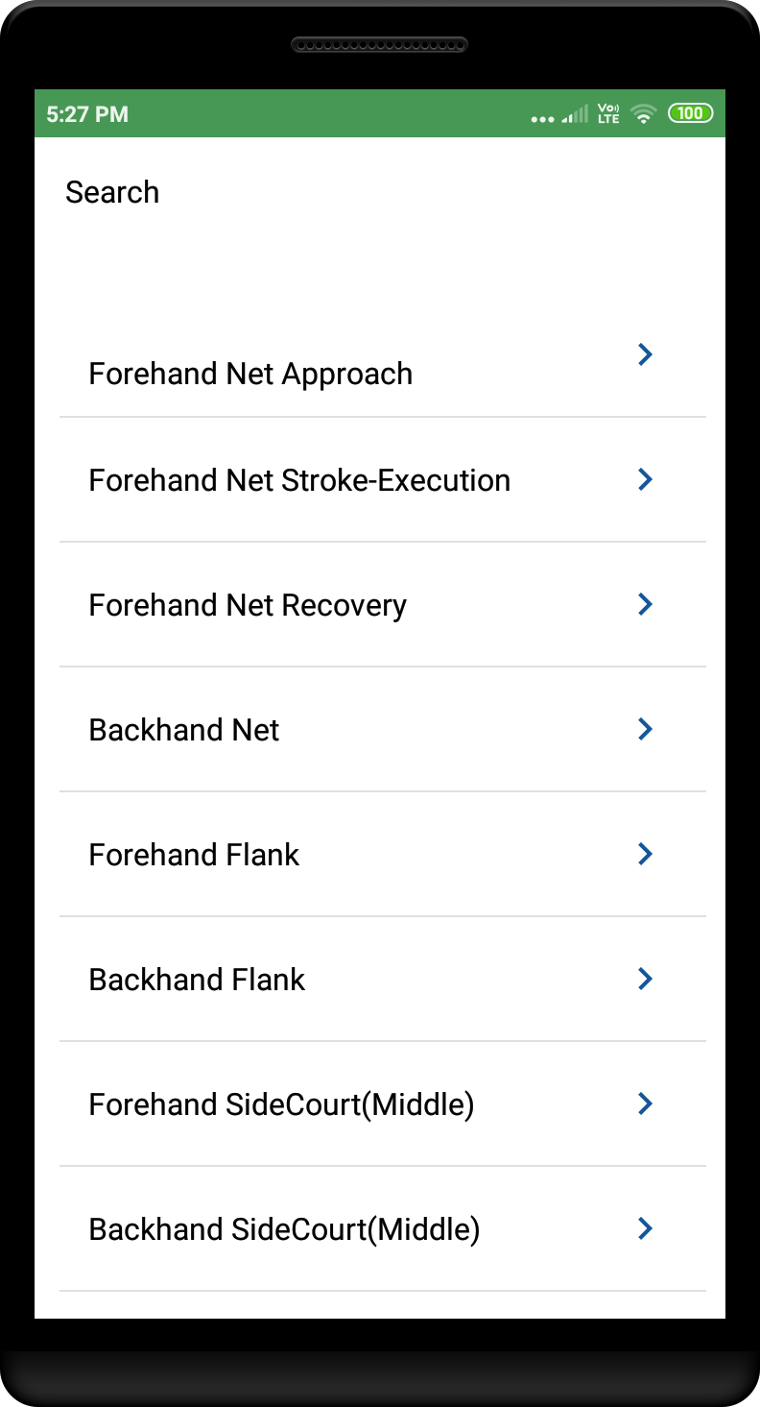

Play Game: Video stops at given pause.

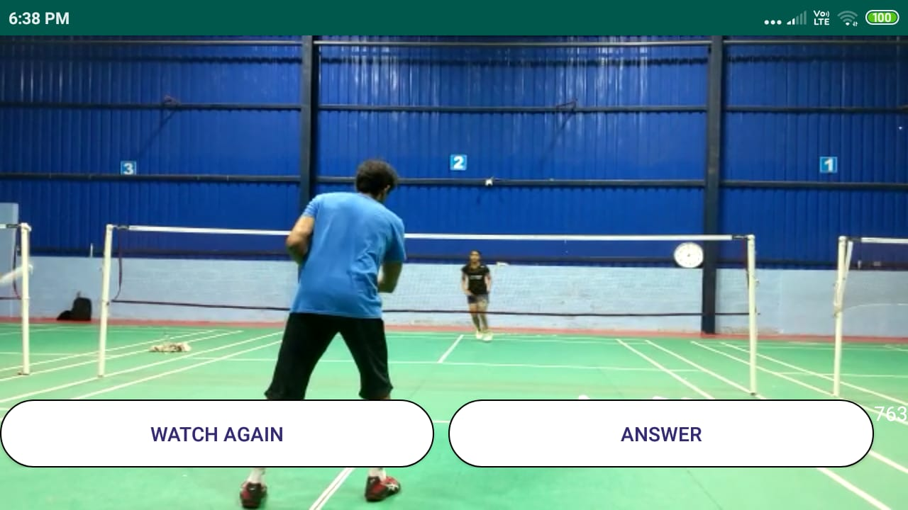

Submit answers based on shot type and shot location shown below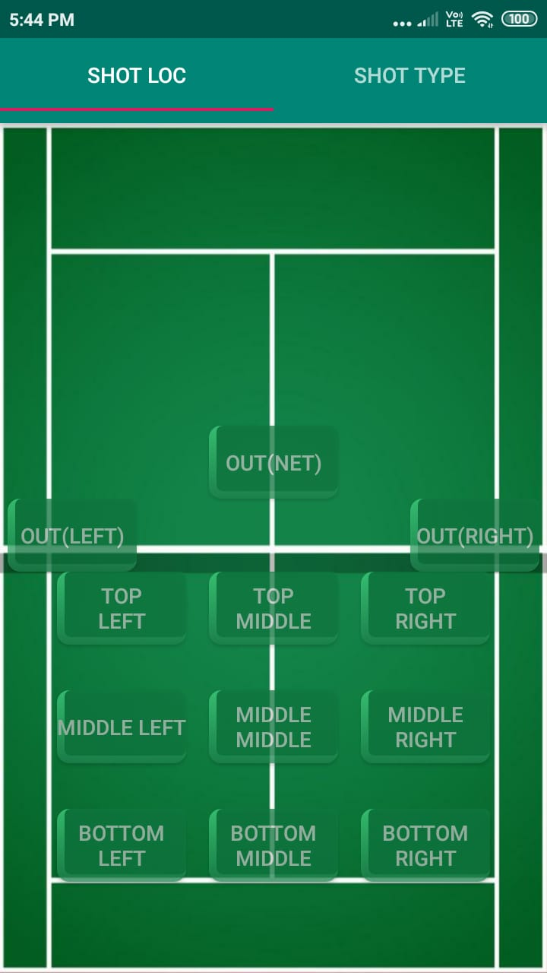

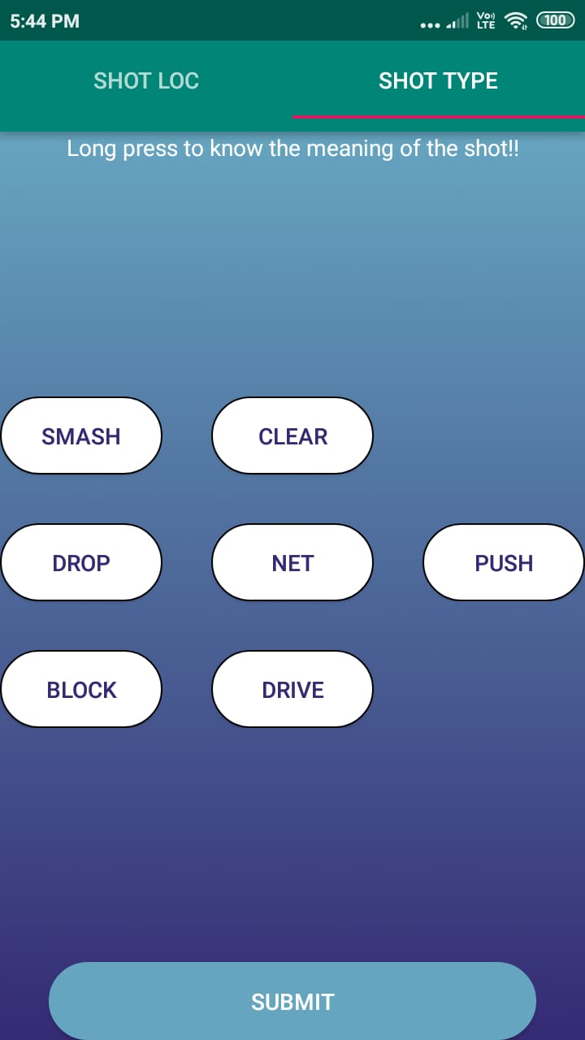

After submitting the answer, asks to confirm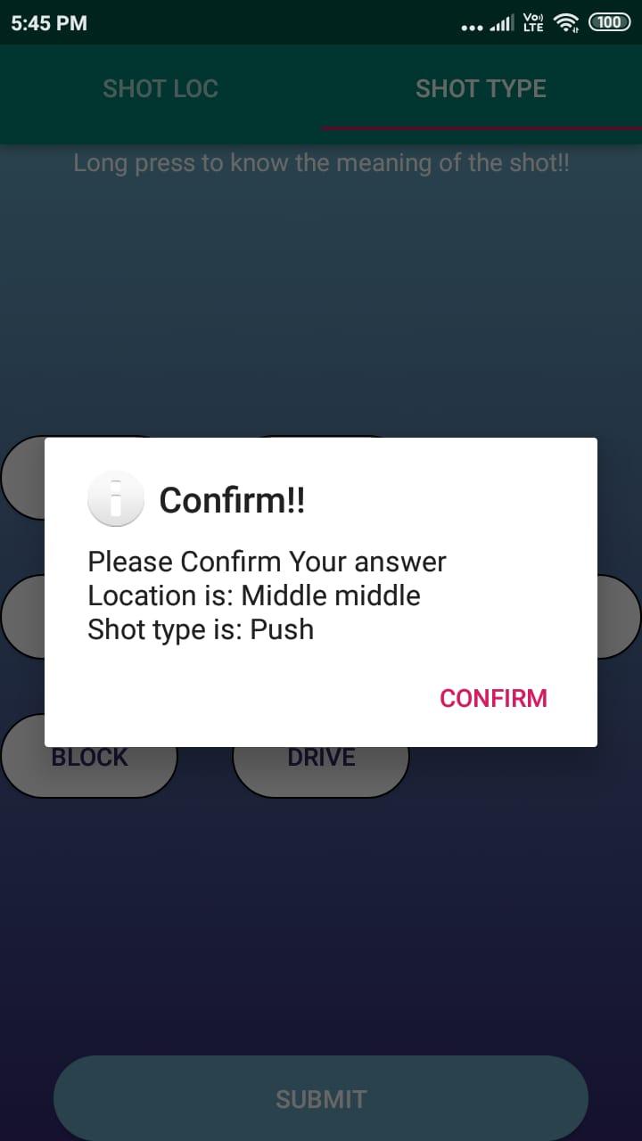

After video is ended, it displays the total score and total time

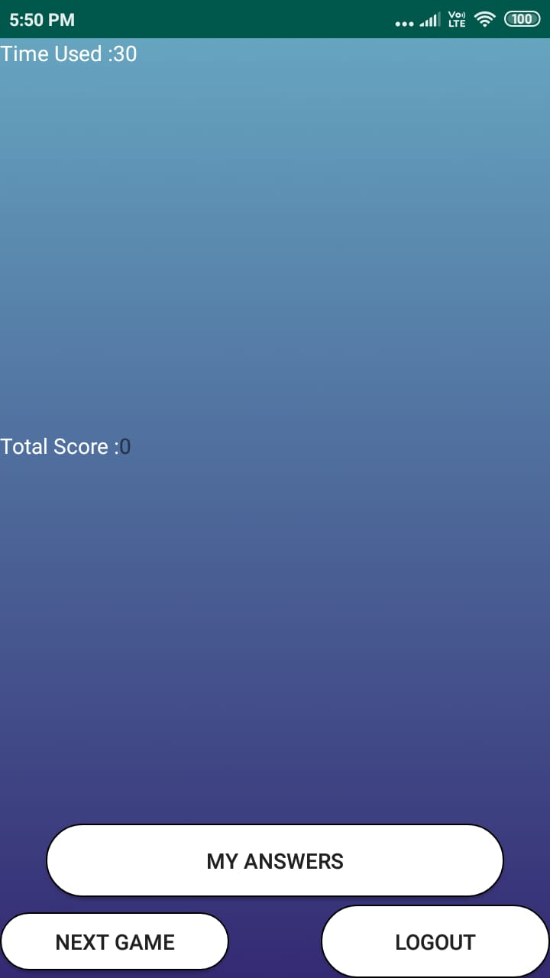

After clicking on MY ANSWERS, shows list of all player answers and associated right answers along with time taken and expected time, shown below.

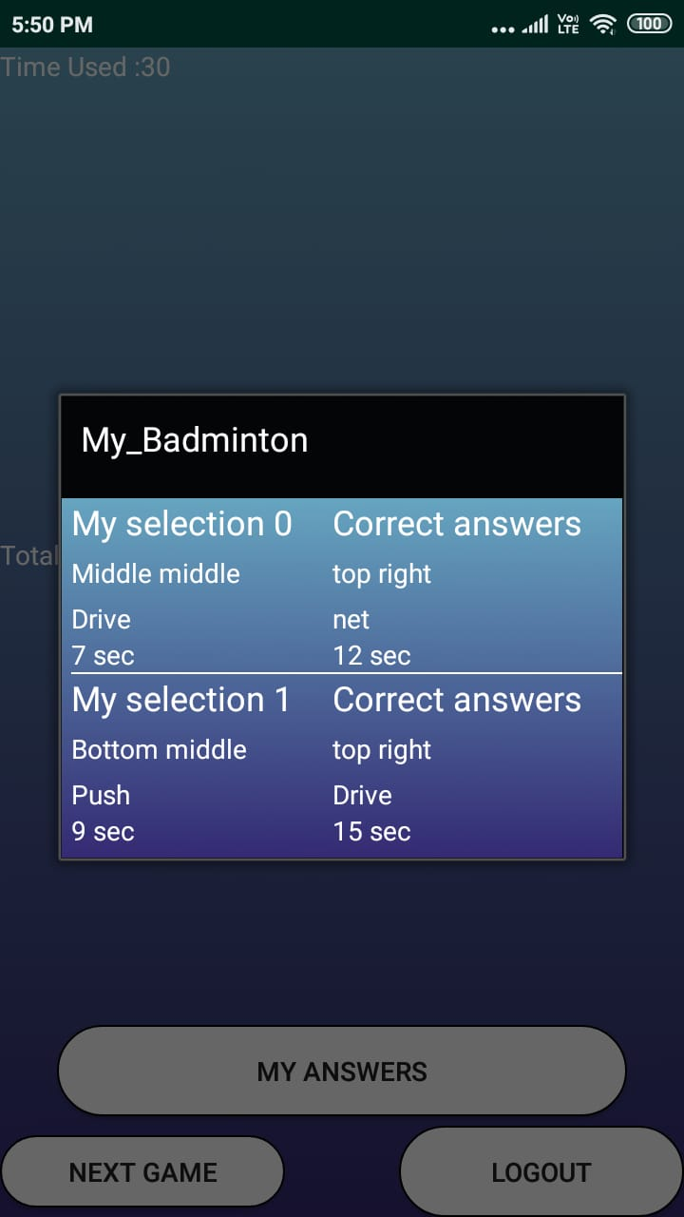

On clicking particular item, can review the video clip.

